Glock-O-Bot

Design Guide

# Version 1.0 SEptember 2016

## Hardware Description

### System Diagram

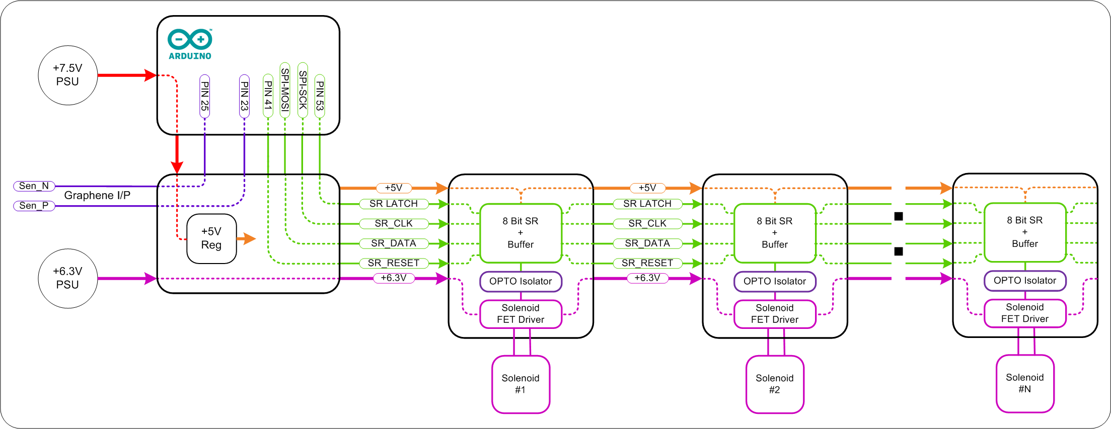

### Schematics

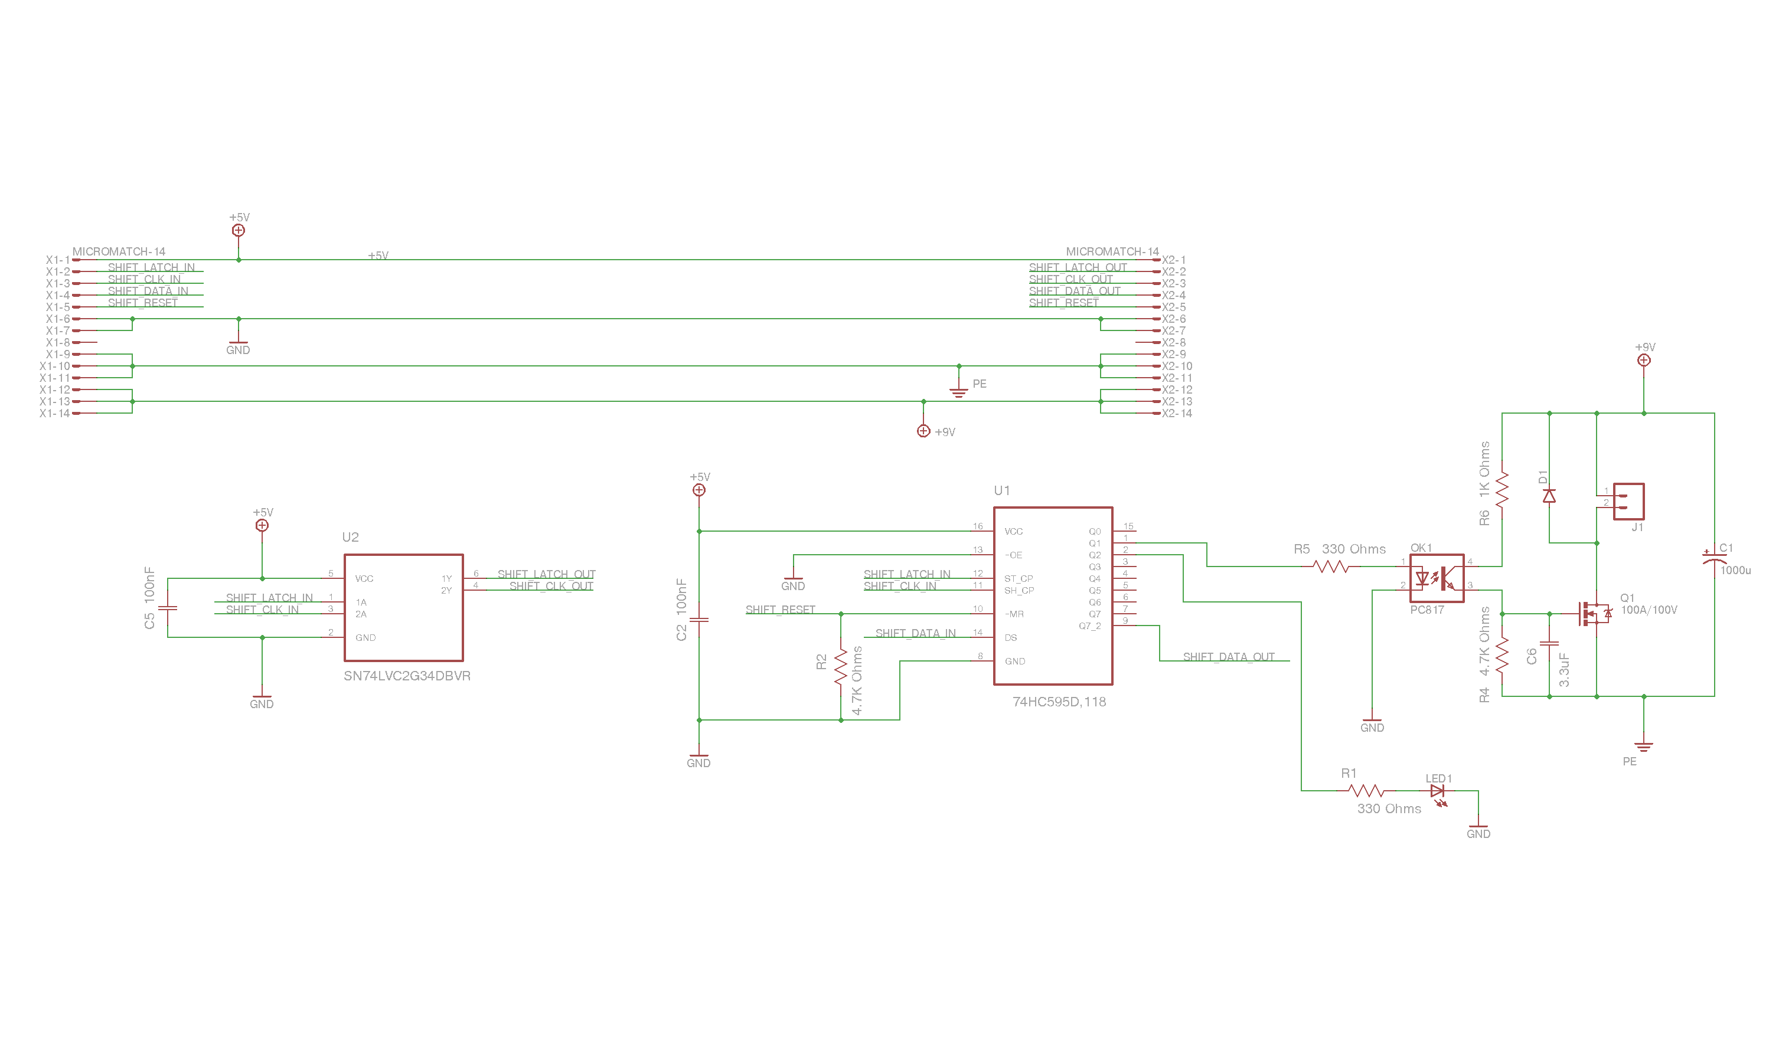

### PCB Layout

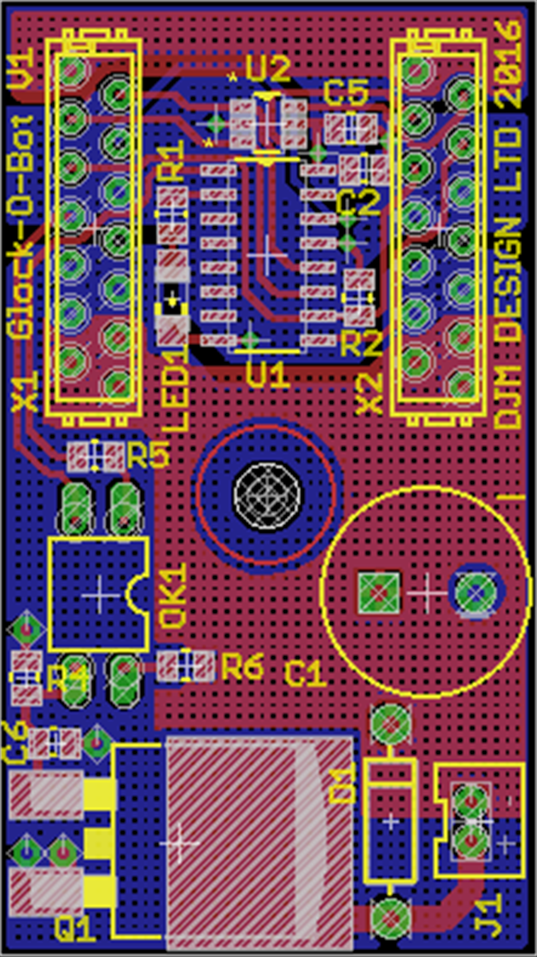

### bill of materials

|  |  |  |  |
| --- | --- | --- | --- |
| **Part** | **Value** | **Description** | **FARNELL** |
| C1 | 1000uF 16V | Capacitor Polarized | 9693610 |
| C2 | 100nF 0805 50V | CAPACITOR, 0805 | 1414663 |
| C5 | 100nF 0805 50V | CAPACITOR, 0805 | 1414663 |
| C6 | 3.3uF 0805 16V | CAPACITOR, 0805 | DO NOT FIT!! |
| D1 | Diode 1N4001 | Diode | 9564993 |
| J1 |  | Standard 2-pin 2mm | 9491856 |
| LED1 | Green | LED 1206 | 8530076 |
| OK1 | FOD817A | SHARP OPTO COUPLER | 2322514 |
| Q1 | BUK9637-100E | Common NMOSFET Parts | 2254193 |
| R1 | 330 Ohms | RESISTOR, 0805 | 2073741 |
| R2 | 47K Ohms | RESISTOR, 0805 | 9333274 |
| R4 | 4.7K Ohms | RESISTOR, 0805 | 9333266 |
| R5 | 330 Ohms | RESISTOR, 0805 | 2073741 |
| R6 | 1K Ohms | RESISTOR, 0805 | 2073606 |
| U1 | 74HC595D,118 | 8-bit serial-in parallel-out shift register | 1201269 |
| U2 | SN74LVC2G34DBVR | DUAL BUFFER GATE | 1470888 |
| X1 | MICROMATCH-14 | Micro Match 14 8-215464-4 / 1-215464-4 | 3784678 |
| X2 | MICROMATCH-14 | Micro Match 14 8-215464-4 / 1-215464-4 | 3784678 |

## Firmware Description

### Flow Diagram

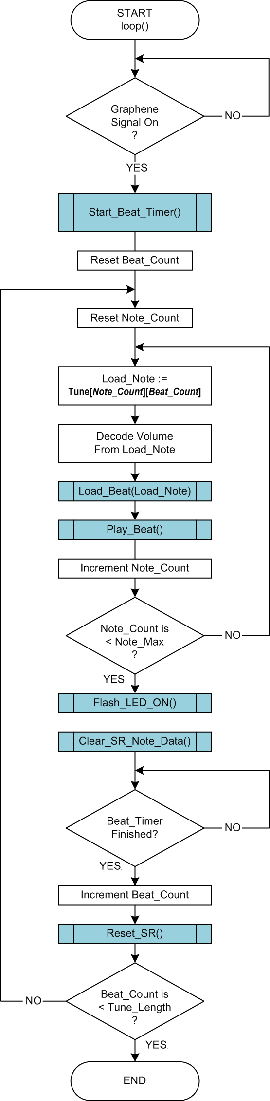

### Tune 2D Array

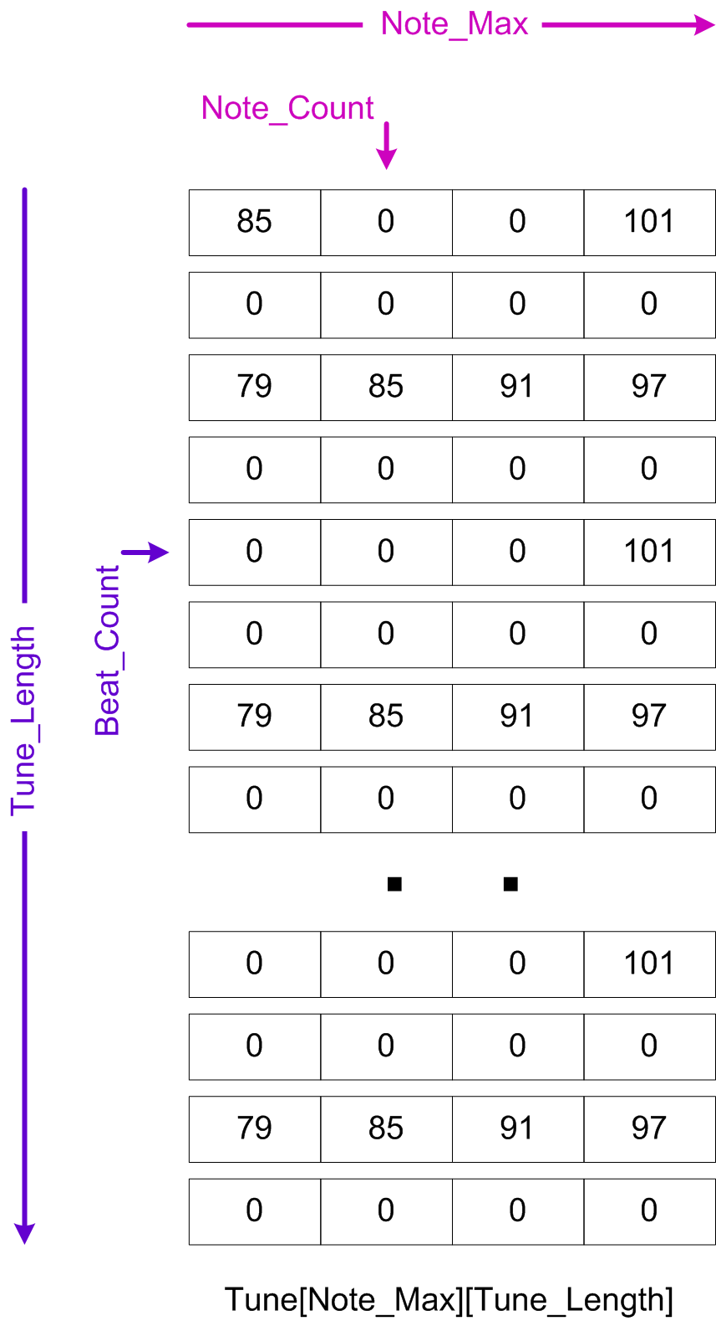

### Key Variable Descriptions

|  |  |
| --- | --- |
| Tune_Length | Used first dimension in the Tune array and is the total number of quantised steps in the tune |
| Note_Max | Used as second dimension in the Tune array and is the number of concurrent single note Tracks |
| Beat_Time | Is the duration of the quantised step in micro seconds and is derived from the Tempo. This is the value used to set the interrupt timer and acts as the main time reference for the tune. |
| Graphene_Signal | Used as the flag when checking if Graphene has signal a start. |
| Next_Beat | Used as a flag to monitor if the interrupt timer has triggered to indicate the start of the next time step. |

### Global Function Description

|  |  |
| --- | --- |
| Clear_SR_Note_Data() | Clears the internal shift register note data array SR_Note_Data[] |
| Clear_SR_LED_Data() | Clears the internal shift register LED data array SR_LED_Data[] |
| Load_Beat(unsigned char Note) | Sets the internal SR data arrays with the correct bits for the note passed to it |
| Flash_LED_ON() | Sends the internal SR LED data array to the Glock-O-Bot |
| Load_LED_SR() | Used to shift the LED data out to Glock-O-Bot with the SPI library functions |
| Play_Beat() | Used to send internal note data to Glock-O-Bot and play the loaded single note |
| Reset_SR() | Clears all bits of the Glock-O-Bot shift register |
| Set_SR() | latches data from Glock-O-Bot SR to its output pins |
| Load_Notes_SR() | Used to shift the note data out to Glock-O-Bot with the SPI library functions |
| Start_Beat_Timer() | Configures and Starts the internal Timer to count for one quantised beat time |
| ISR(TIMER1_OVF_vect) | Interrupt subroutine called when Timer on expires |

## Midi File Conversion

### Anvil Studio

First download and install Anvil Studio from: <http://www.anvilstudio.com/>

Make sure you have opened an empty file so that there aren’t any fixed preferences

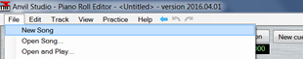

Go into Edit / Preferences

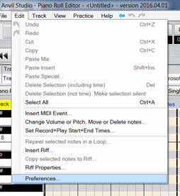

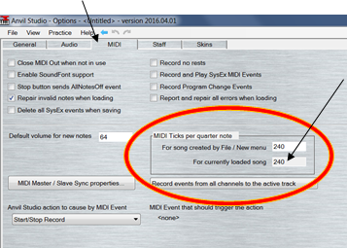Click on the midi tab

!!! MAKE SURE TICKS = 240!!!

this will make for smooth integer quantization

Next import your midi file by clicking on merge song, and browse to your file

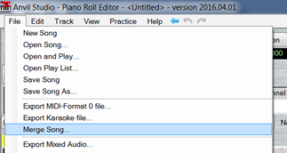

For the purpose of this guide I am using a short tune from the Super Mario game

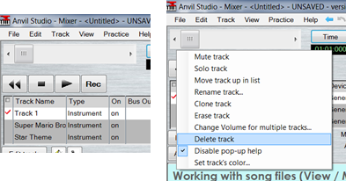You will have an extra track but you can delete it by right clicking the tick on the left and selecting delete track

By default, you will be in the mixer view

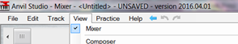

However, to change the view to the “Piano Roll Editor” to check that you have only one note playing at a time in each track, which is important given how the Arduino code works. Remember to check each of your tracks separately by selecting them in the viewer. Remember the recommendation to limit the maximum of concurrently played tracks to four.

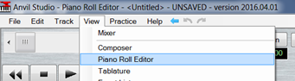

While doing this you will also want to check what the smallest time value of a note is in all the tracks, this will be used to align all the notes to a fixed grid (timeline). This typically ranges from a quarter note to thirty tooth of a note (demisemiquaver) and set the granularity of the Arduino’s time-base.

In this example it is 16th note as all the smallest notes start on at least the 16th’s line

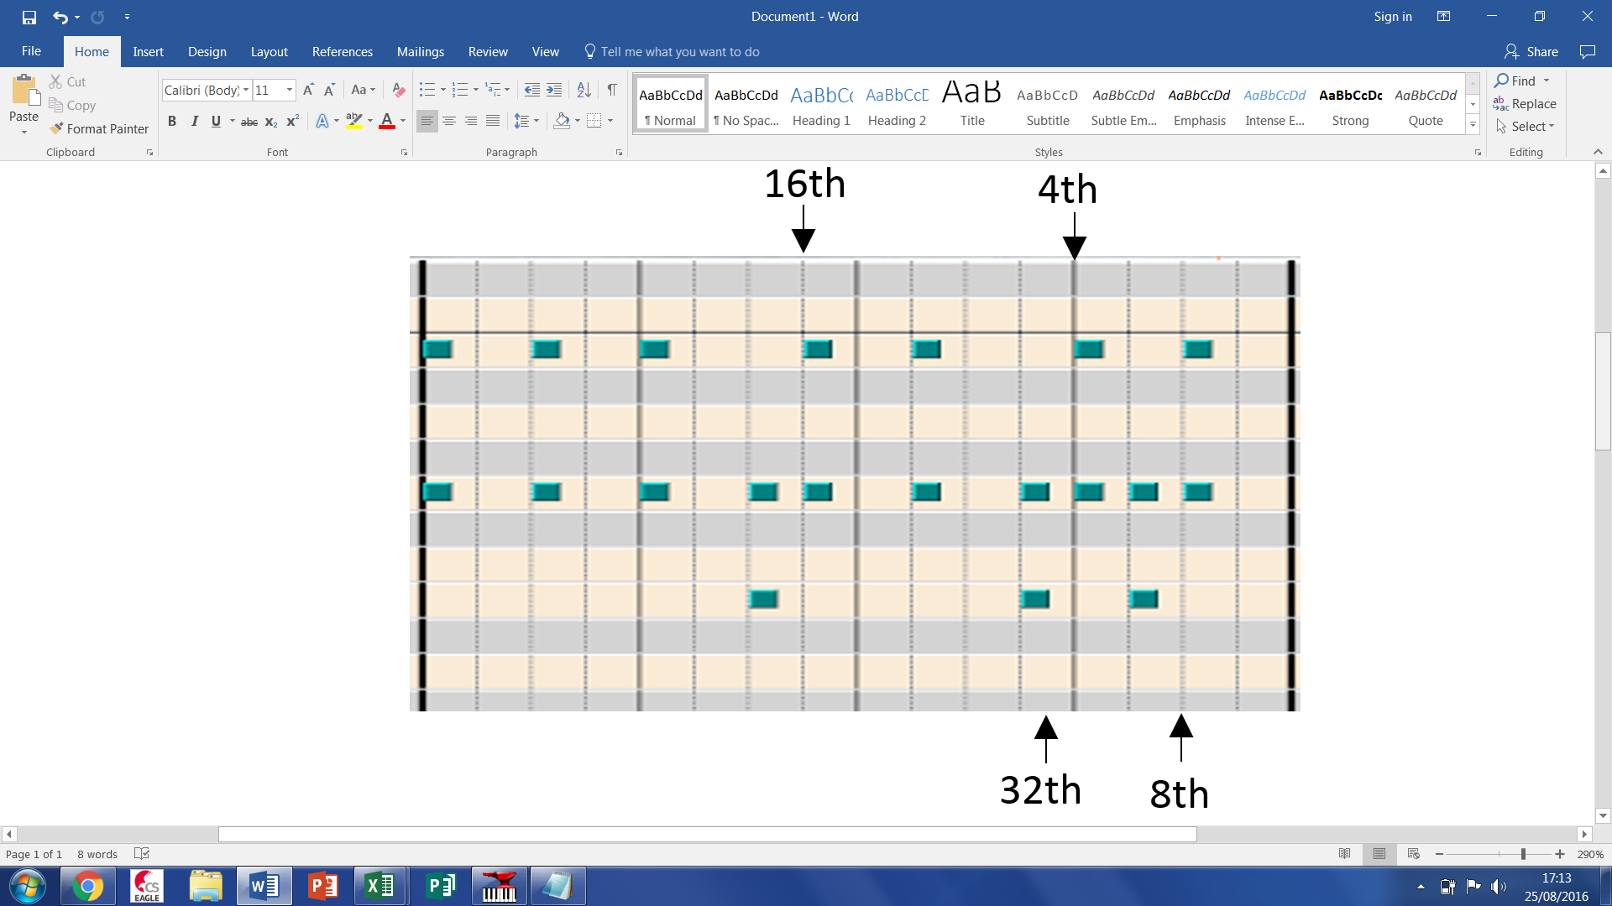

Once you have checked all your tracks you will have to quantize (Align the notes) with the smallest value you just found:

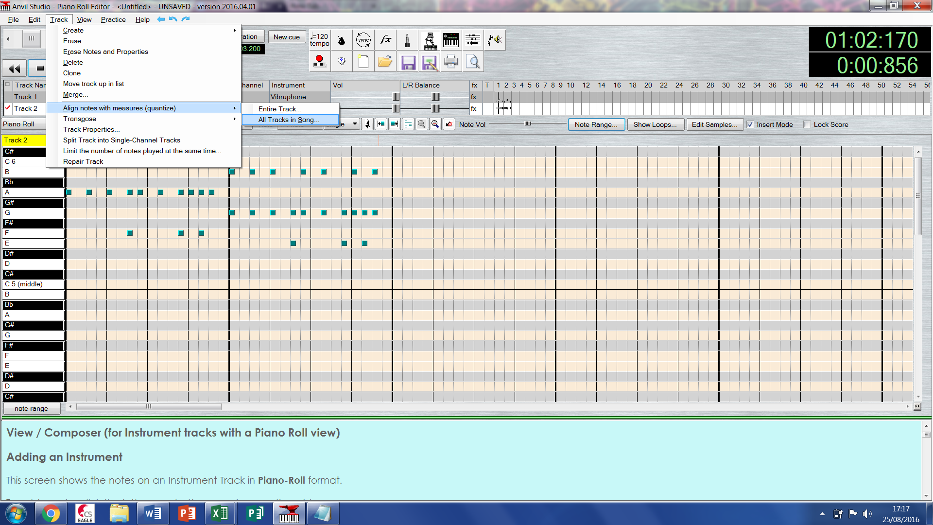

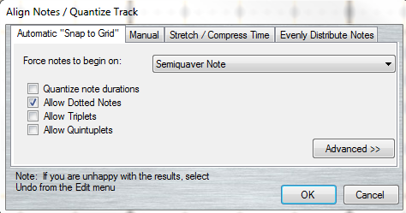

The Glock-O-Bot only has a Midi note range from 79-109, so you may need to transpose your tracks to bring them into the range. You can view the Midi notes being played by switching to the event viewer and scrolling through each selected track. To go into the event list sect View / Event List

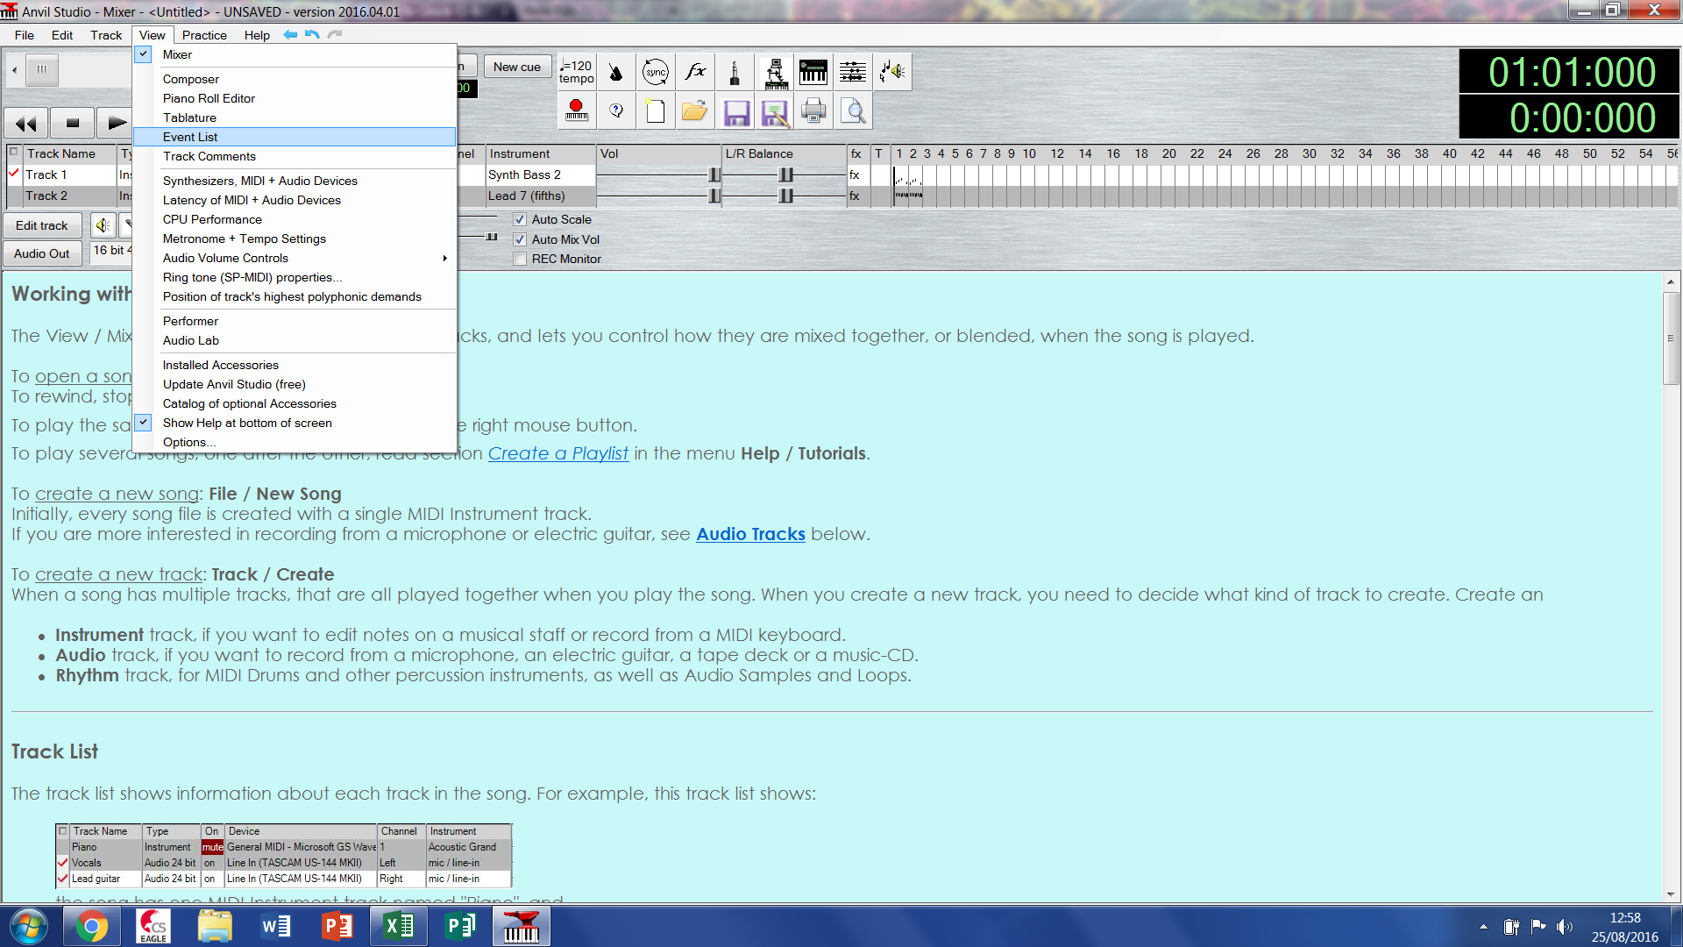

It should look something like this

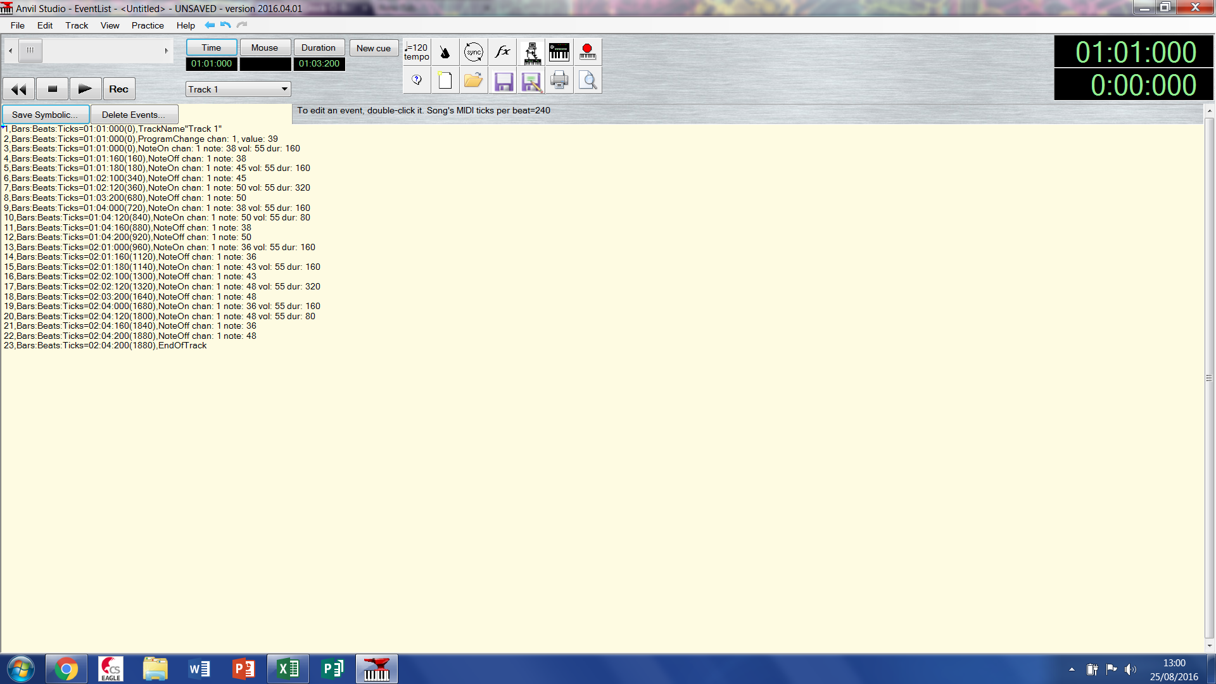

If the notes are out of range, they can be shifted up or down using the Track / Transpose / Entire Track...

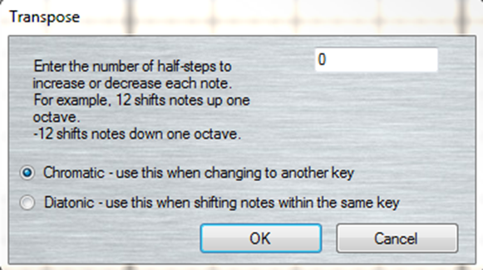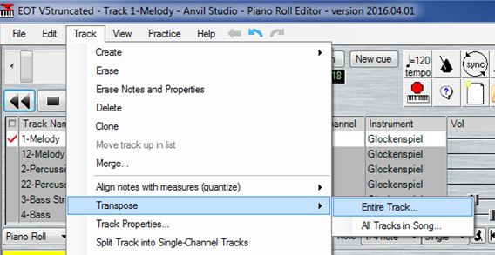

Now you are ready to export your edited tracks to text files, but first make sure you have set your time mode to bars beats and ticks

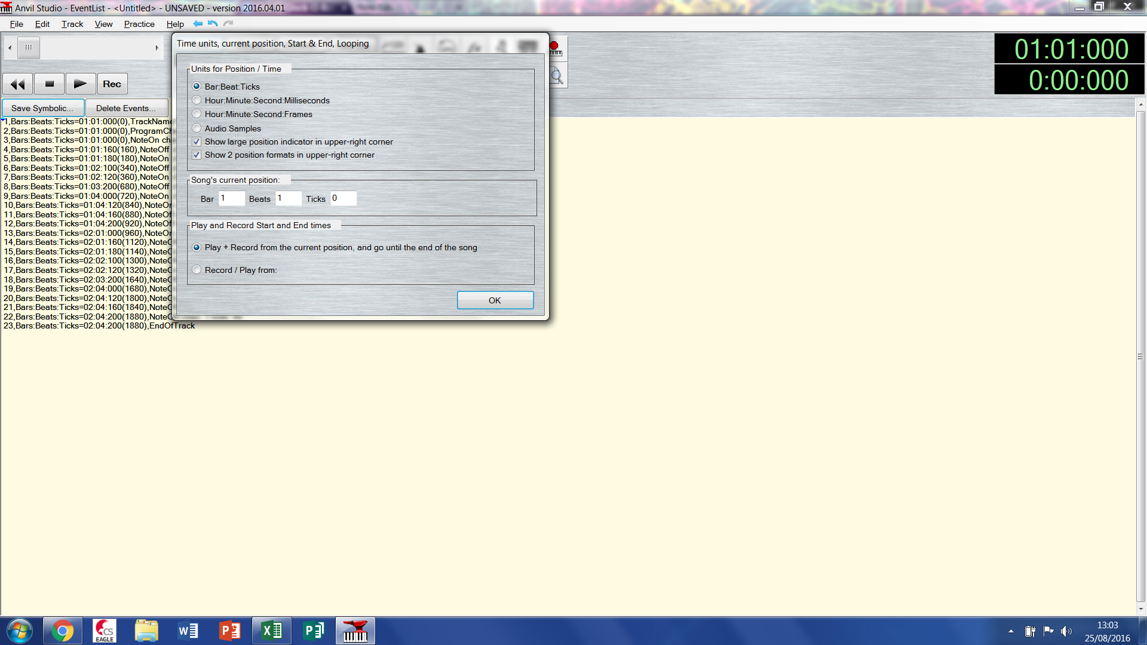

Use the ‘Save Symbolic’ button in the Event List viewer to save each of your tracks separately to a text file.

The example below would save Track 1 as this is selected the currently selected track.

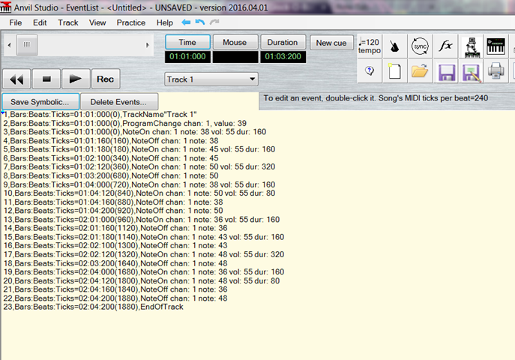

### Event List Text File Processing

In order to import the data from the event list text files into Excel, the data needs to be correctly delimited. This can be done using find and replace on text strings in Notepad and adding in the colons so that that all the data is properly delimited by a unique character (i.e. colon :)

Before: After:

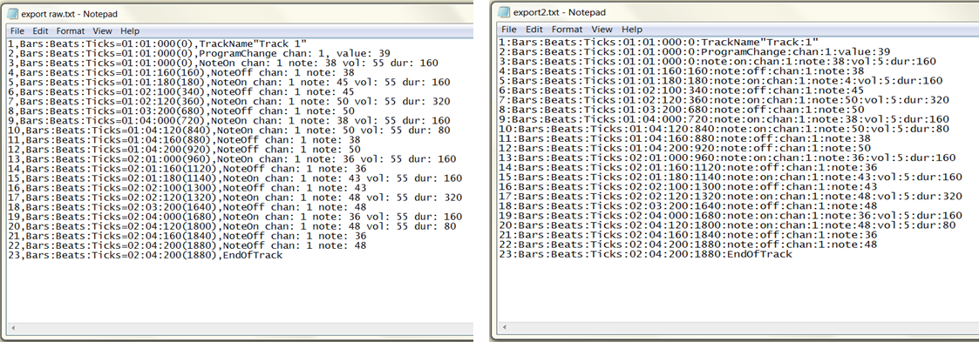

Each tracks event list can them be imported into an Excel file using the text import wizard shown below:

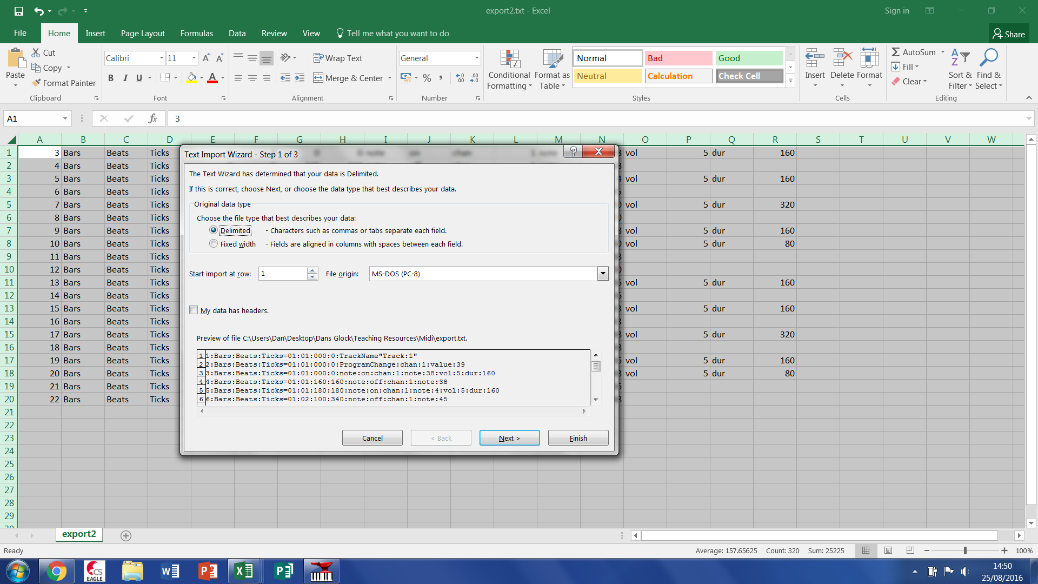

First click next, then the empty box and type “:” without the quote marks, finally click finished

### EVENT LIST EXCEL FILE PROCESSING

You should then see something like this in Excel:

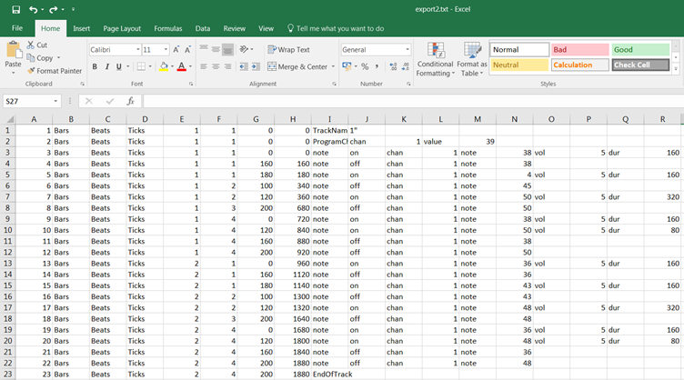

Delete the first few header rows and last few footer rows, to leave just the note on and note off events

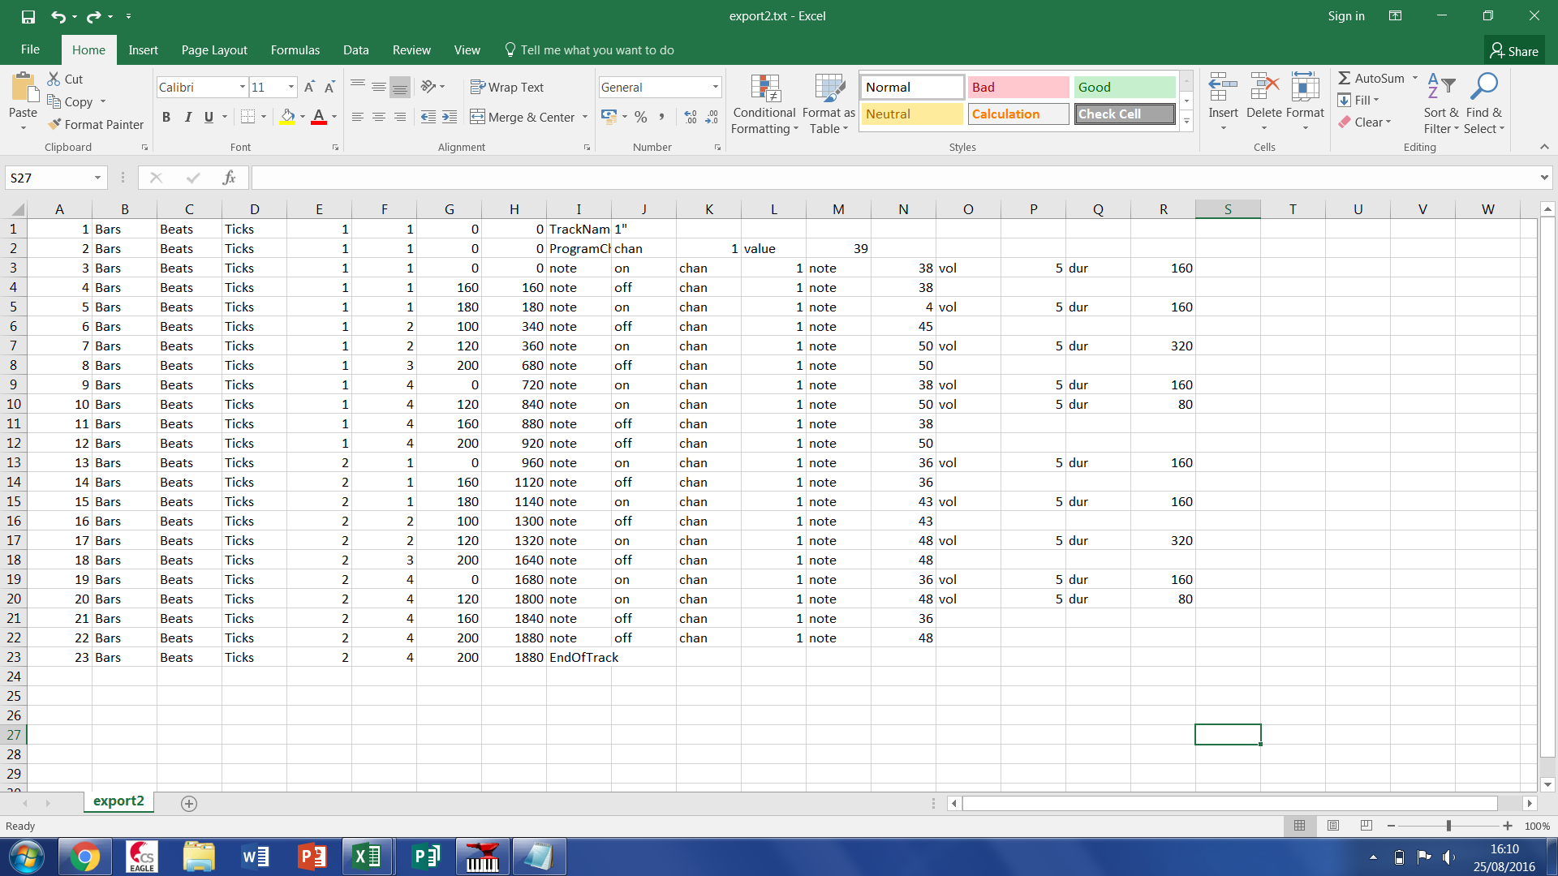

Then select the whole spreadsheet and sort the data using the column with on off in (column J below):

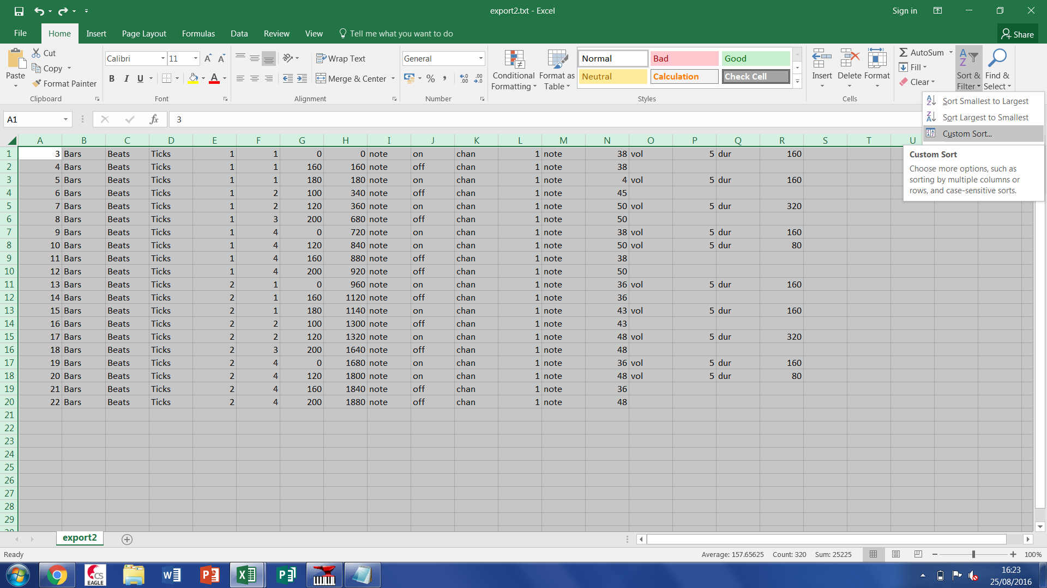

Sort alphabetically by column J:

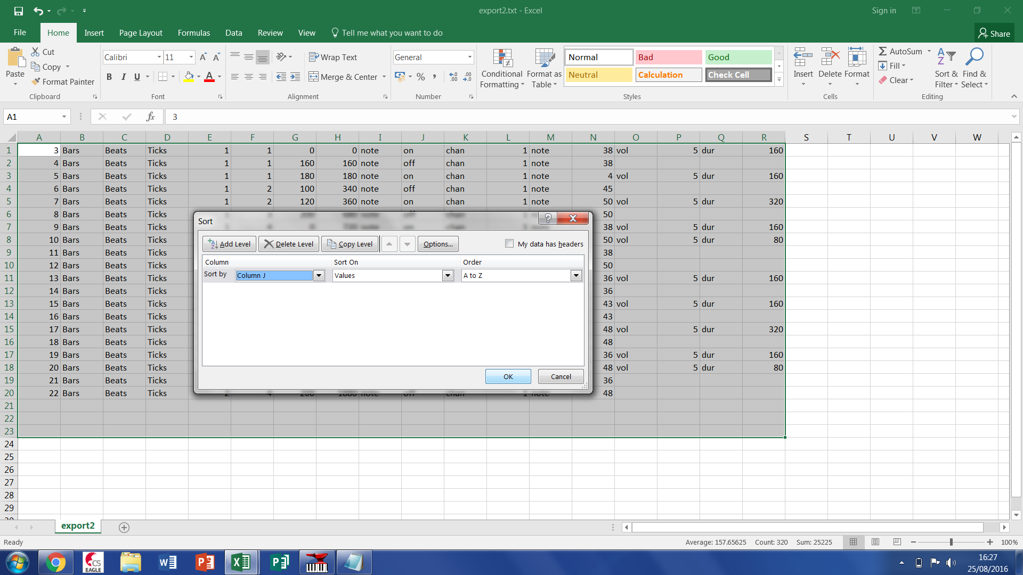

Then delete all the rows that say note off because we only need to know when the note starts:

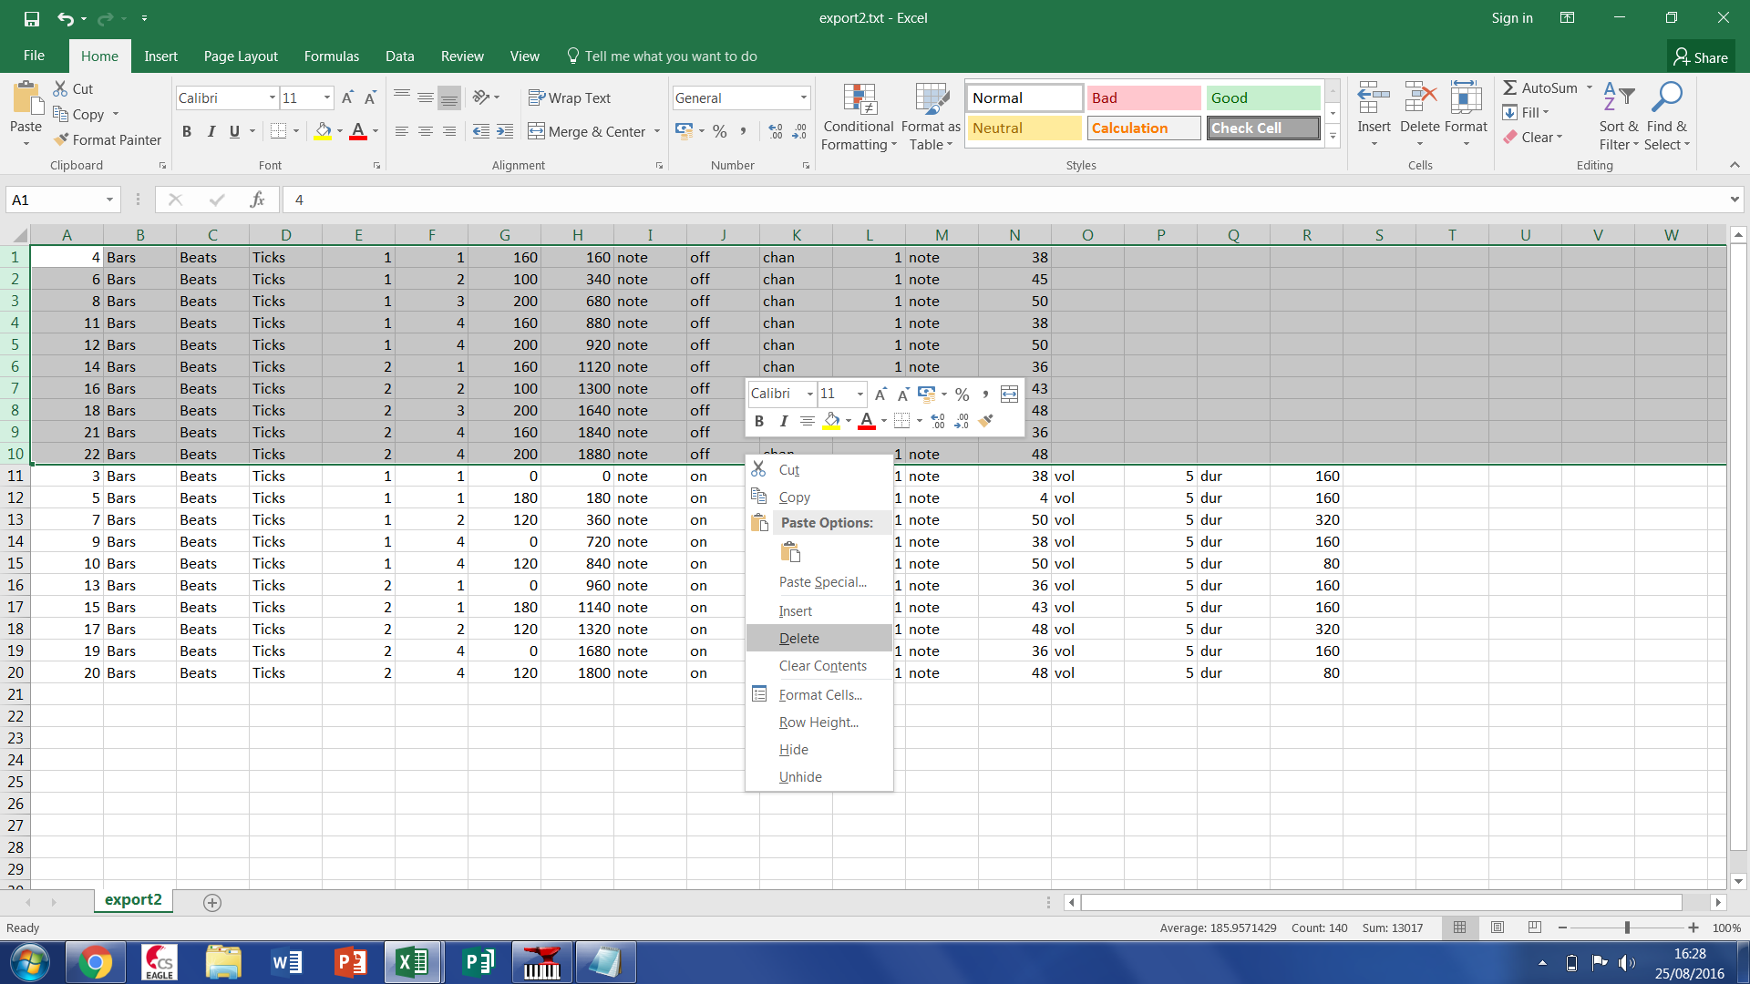

Now add two new worksheet tabs at the base naming one “Align” and the other “CSV”:

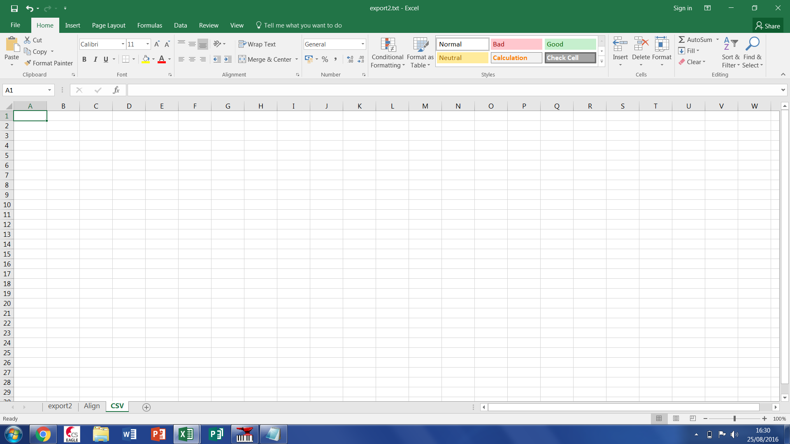

Make an extra column after the total number of ticks

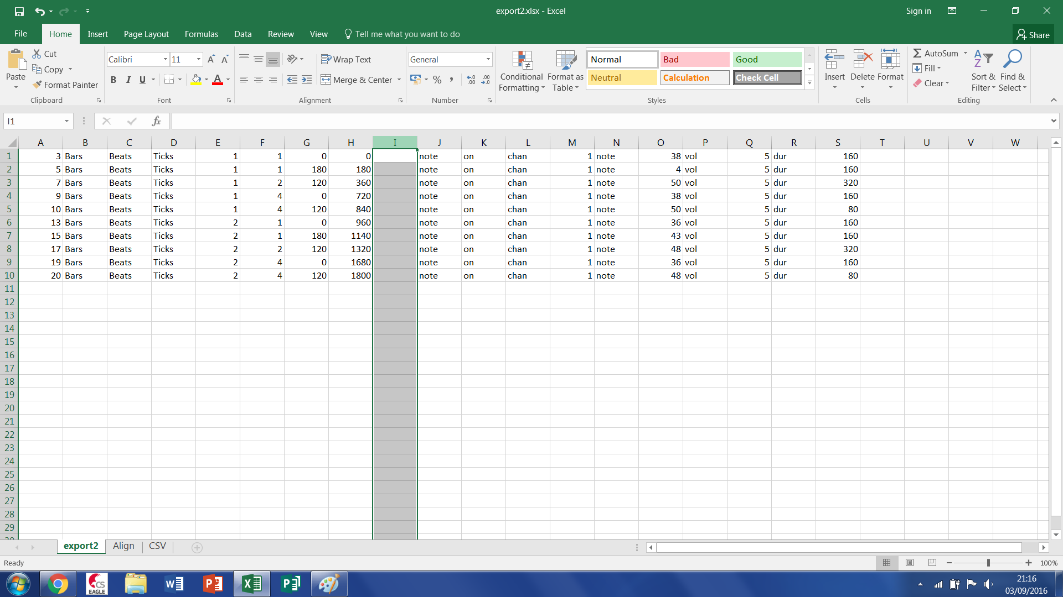

Input the cell equation = H1 / (value of Ticks per smallest note) and drag down so the column has the same length as the adjacent ones. The values in this column equate to the time base values when an associated note should be played.

You calculated the smallest note size during quantization in section 1.1 and we set 240 Ticks per quarter note in the initial preferences setup. So the value used could be:

|  |  |  |
| --- | --- | --- |
| Crotchet | 1/4 | 240 |
| Quaver | 1/8 | 120 |
| Semiquaver | 1/16 | 60 |
| Demisemiquaver | 1/32 | 30 |

In this example the quantization was to a 16th so we put = H1/60 in the function box

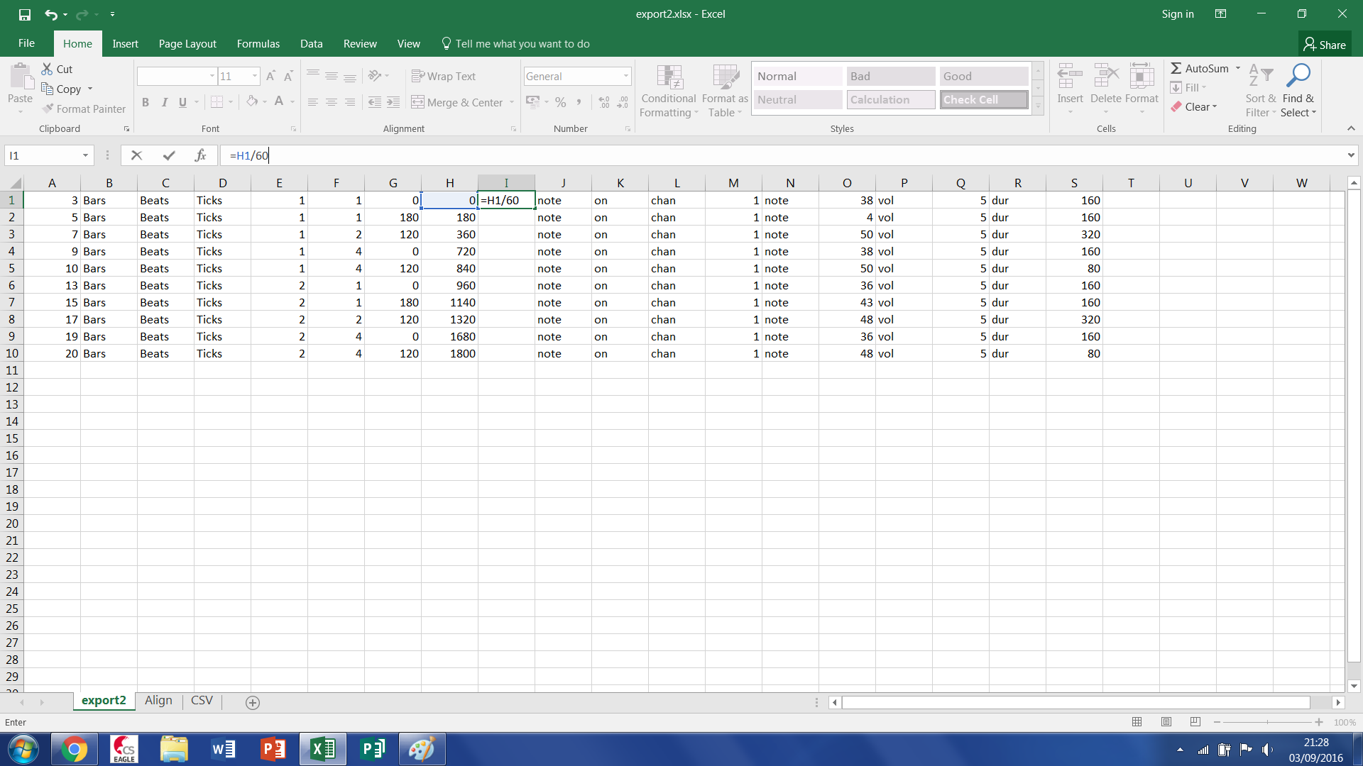

The last value in this column should be noted and compared the last value for in the same column for all your other tracks. The largest value defining the maximum length of you tune and the dimension of the notes array (***Tune_Length***)

Open the Align worksheet and add in all the numbers from 1 to maximum tune length selected above. (You can do this by typing in the number 1 into the first cell and dragging it down a few places and selecting the option fill series and dragging it down to the maximum tune length value.)

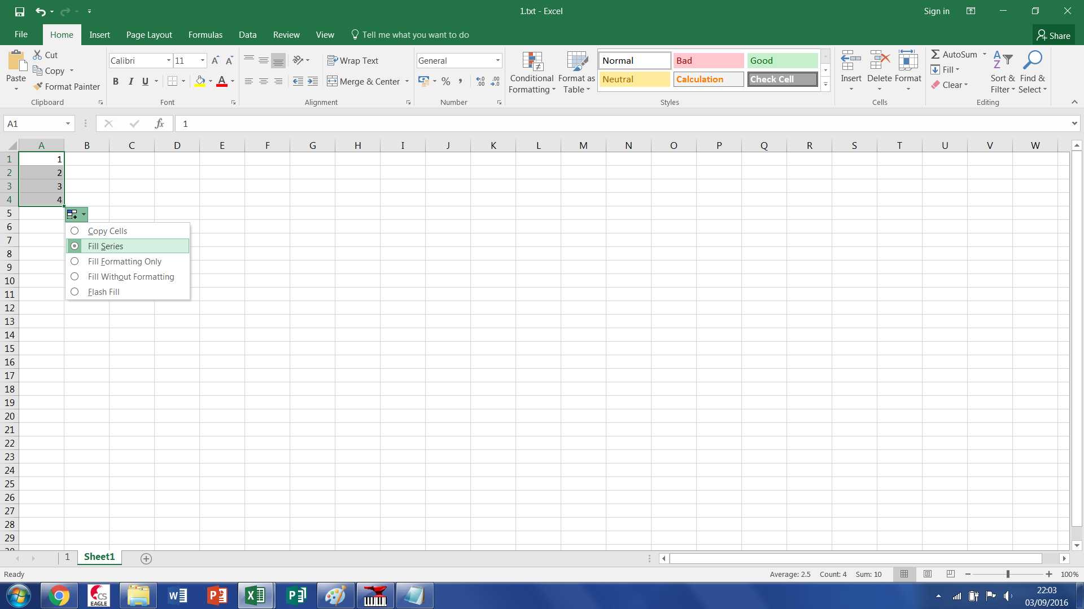

In the Align work book paste the time base values from column I in the first (export2) work book to column D and take note of its length in terms of the row in which the final value is. (Note only paste values)

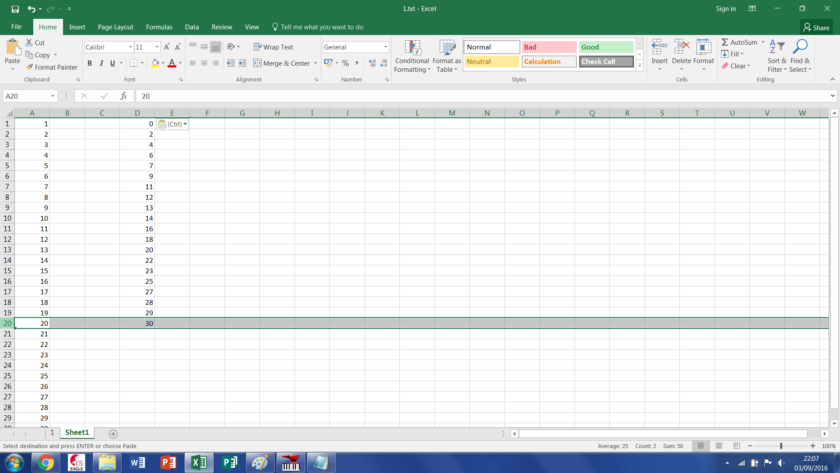

In the Align work book paste the note values from column O in the first (export2) work book to column E. We now have the time base values of when a note should be played in column D and the corresponding note to be played in column E.

For our data array which is sized to the maximum tune length we need fill it with the appropriate notes at the associated time base location and fill all other locations with zero. To do this we use the following Excel function

= IFERROR(VLOOKUP(A1,$D$1:$E$*Length*,2,FALSE),0) where *Length* is the row number with the final value of column E in

Place this formula in cell B1 and drag down to the end of column A

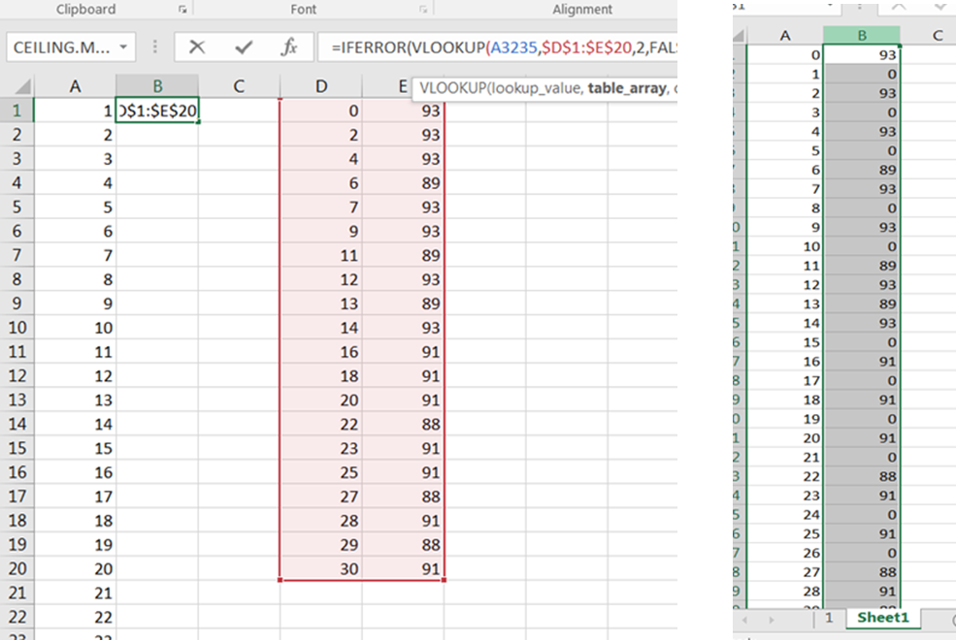

Select and copy these values from column B and open the CSV work book

Paste the values into column A in the CSV work book (Note only paste values) and insert two blank rows above it.

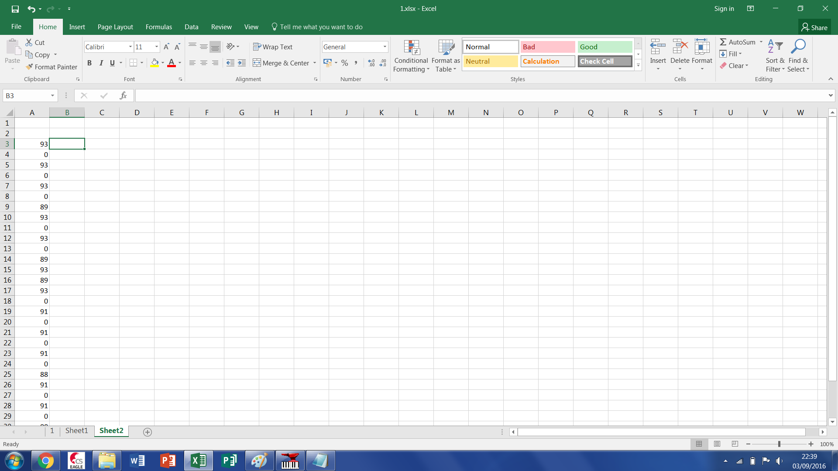

Then using copy and paste-transpose pivot the data in column A so that it is stored horizontally in row1. This ensures each value is exported with a comma delimiter when the work sheet is save as a CSV file.

First save the document as an excel document and then with the CSV workbook open, as a .CSV file. The data in this file can be used directly in the Glock-O-Bot code.

Repeat all steps in this section for each track you have exported out of Anvil Studio.

### IMPORT INTO ARDUINO CODE

Rename the CSV file to (document name).txt open text file with Notepad and select all and copy the data. In Arduino paste it between the curly brackets in the Glock-O-Bots code in the position highlighted below, repeat for all your tracks.

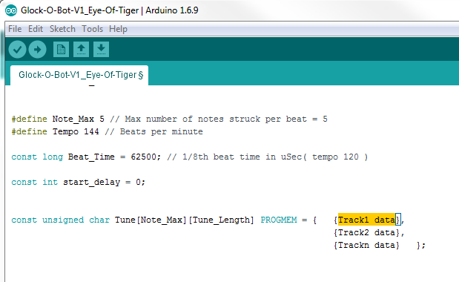

Remember to set the key variables to match your midi track conversion.